Environment variables for Azure Key Vault secrets
Environment variables allow for referencing secrets stored in Azure Key Vault. These secrets are then made available for use within Power Automate flows and custom connectors. Notice that the secrets aren't available for use in other customizations or generally via the API.
The actual secrets are stored in Azure Key Vault and the environment variable references the key vault secret location. Using Azure Key Vault secrets with environment variables require that you configure Azure Key Vault so that Power Platform can read the specific secrets you want to reference.
Environment variables referencing secrets aren't currently available from the dynamic content selector for use in Power Automate flows.
Configure Azure Key Vault
To use Azure Key Vault secrets with Power Platform, the Azure subscription that has the vault must have the PowerPlatform resource provider registered and the user who creates the environment variable must have appropriate permissions to the Azure Key Vault resource.
- Register the Microsoft.PowerPlatform resource provider in your Azure subscription. Follow these steps to verify and configure: Resource providers and resource types
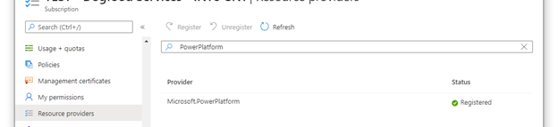
- Create an Azure Key Vault vault. Consider using a separate vault for every Power Platform environment to minimize the threat in case of a breach. Consider configuring your key vault to use Azure role-based access control for the Permission model. More information: Best practices for using Azure Key Vault, Quickstart - Create an Azure Key Vault with the Azure portal
- Users who create or use environment variables of type secret must have permission to retrieve the secret contents. To grant a new user the ability to use the secret, select the Access control (IAM) area, select Add, and then select Add role assignment from the dropdown. More information: Provide access to Key Vault keys, certificates, and secrets with an Azure role-based access control
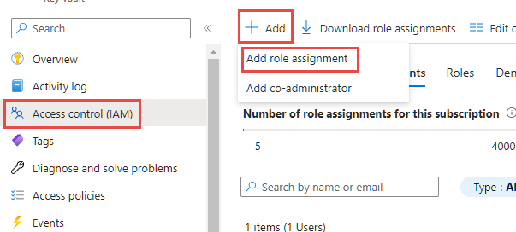
- On the Add role assignment wizard, leave the default assignment type as Job function roles and continue to the Role tab. Locate the Key Vault Secrets User role and select it. Continue to the members tab and select the Select members link and locate the user in the side panel. When you have the user selected and shown on the members section, continue to the review and assign tab and complete the wizard.
- Azure Key Vault must have the Key Vault Secrets User role granted to the Dataverse service principal. If it doesn't exist for this vault, add a new access policy using the same method you previously used for the end user permission, only using the Dataverse application identity instead of the user. If you have multiple Dataverse service principals in your tenant, then we recommend that you select them all and save the role assignment. Once the role is assigned, review each Dataverse item listed in the role assignments list and select the Dataverse name to view the details. If the Application ID isn't 00000007-0000-0000-c000-000000000000**, then select the identity, and then select Remove to remove it from the list.
- If you have enabled Azure Key Vault Firewall, you have to allow Power Platform IP addresses access to your key vault. Power Platform isn't included in the "Trusted Services Only" option. Go to Power Platform URLs and IP address ranges for the current IP addresses used in the service.

Create a new environment variable for the Key Vault secret
Once Azure Key Vault is configured and you have a secret registered in your vault, you can now reference it within Power Apps using an environment variable.
- Sign on to Power Apps, and in the Solutions area, open the unmanaged solution you're using for development.
- Select New > More > Environment variable.
- Enter a Display name and optionally, a Description for the environment variable.
- Select the Data Type as Secret and Secret Store as Azure Key Vault.
- Choose from the following options:
  - Select New Azure Key Vault value reference. After the information is added in the next step and saved, an environment variable value record is created.
  - Expand Show default value, to display the fields to create a Default Azure Key Vault secret. After the information is added in the next step and saved, the default value demarcation is added to the environment variable definition record.
- Enter the following information:
  - Azure Subscription ID: The Azure subscription ID associated with the key vault.
  - Resource Group Name: The Azure resource group where the key vault that contains the secret is located.
  - Azure Key Vault Name: The name of the key vault that contains the secret.
  - Secret Name: The name of the secret located in Azure Key Vault.
- Select Save.

Create a Power Automate flow to test the environment variable secret
A simple scenario to demonstrate how to use a secret obtained from Azure Key Vault is to create a Power Automate flow to use the secret to authenticate against a web service.
- Sign into Power Apps, select Solutions, and then open the unmanaged solution you want. If the item isn’t in the side panel pane, select …More and then select the item you want.
- Select New > Automation > Cloud flow > Instant.
- Enter a name for the flow, select Manually trigger a flow, and then select Create.
- Select New step, select the Microsoft Dataverse connector, and then on the Actions tab select Perform an unbound action.
- Select the action named RetrieveEnvironmentVariableSecretValue from the dropdown list.
- Provide the environment variable unique name (not the display name) added in the previous section, for this example new_TestSecret is used.
- Select ... > Rename to rename the action so that it can be more easily referenced in the next action. In this screenshot, it's renamed to GetSecret.
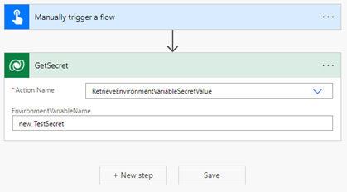
- Select ... > Settings to display the GetSecret action settings.
- Enable the Secure Outputs option in the settings, and then select Done. This is to prevent the output of the action getting exposed in the flow run history.
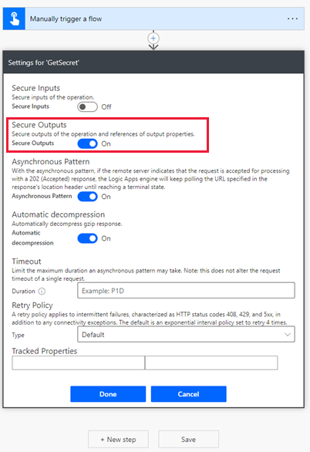
- Select New step, search, and select the HTTP connector.
- Select the Method as GET and enter the URI for the web service. In this example, the fictitious web service httpbin.org is used.
- Select Show advanced options, select the Authentication as Basic, and then enter the Username.
- Select the Password field, and then on the Dynamic content tab under the flow step name above (GetSecret in this example) select RetrieveEnvironmentVariableSecretValueResponse EnvironmentVariableSecretValue, which is then added as an expression outputs('GetSecretTest')?['body/EnvironmentVariableSecretValue'] or body('GetSecretTest')['EnvironmentVariableSecretValue'].
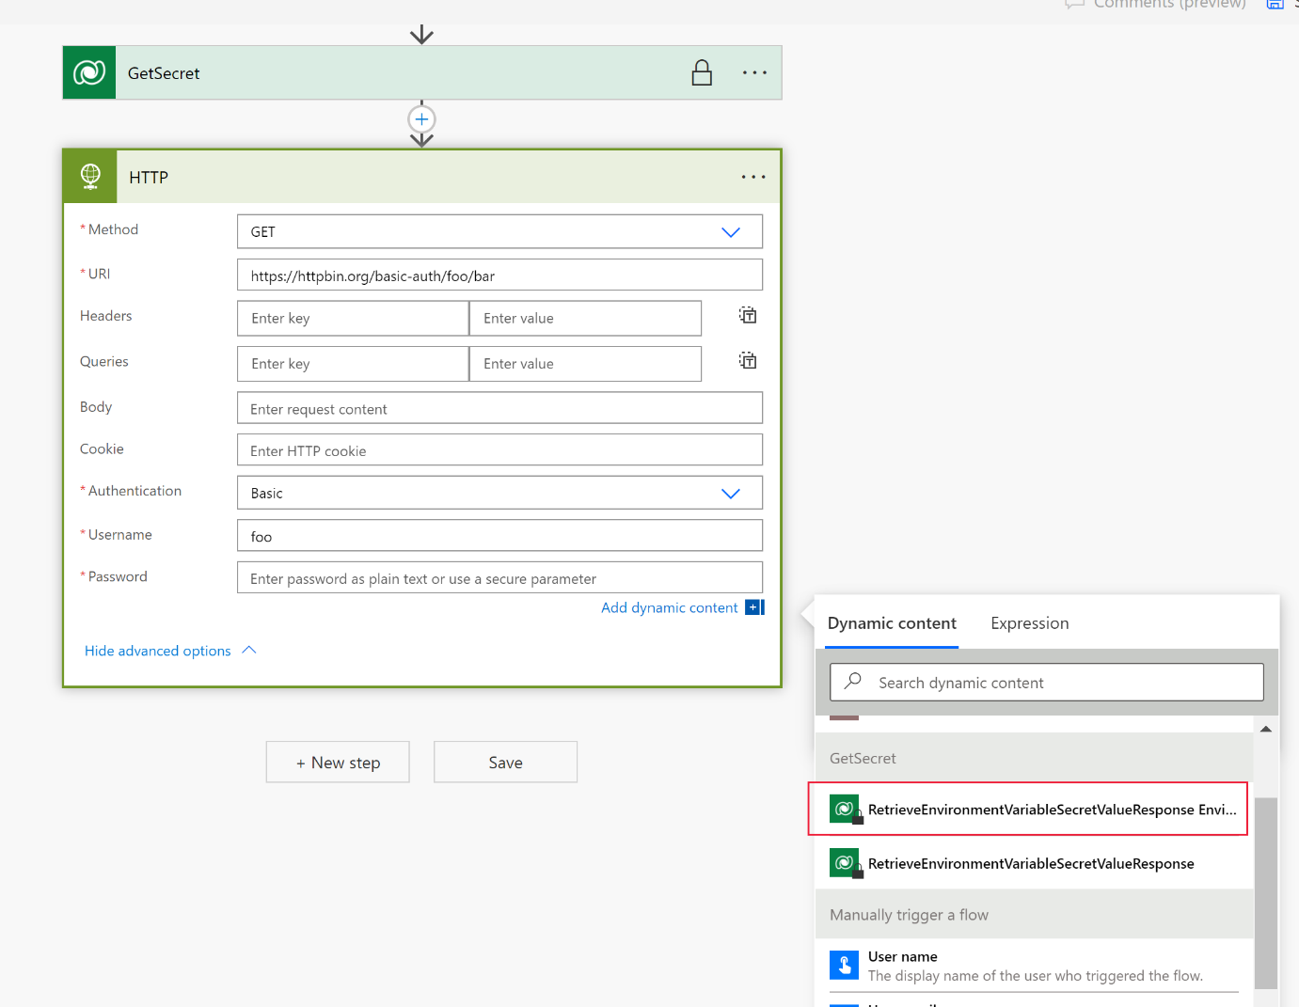
- Select ... > Settings to display the HTTP action settings.
- Enable the Secure Inputs and Secure Outputs options in the settings, and then select Done. Enabling these options prevents the input and outputs of the action getting exposed in the flow run history.
- Select Save to create the flow.
- Manually run the flow to test it.
Using the run history of the flow, the outputs can be verified.


